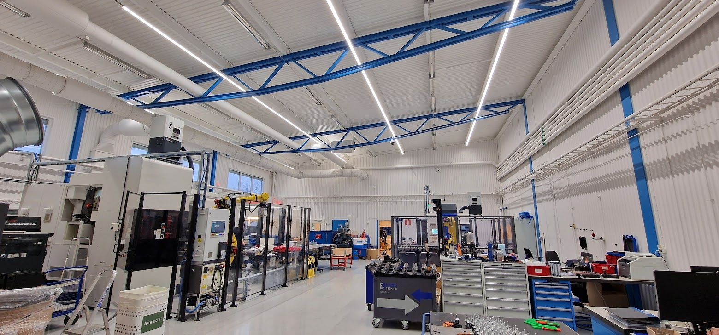

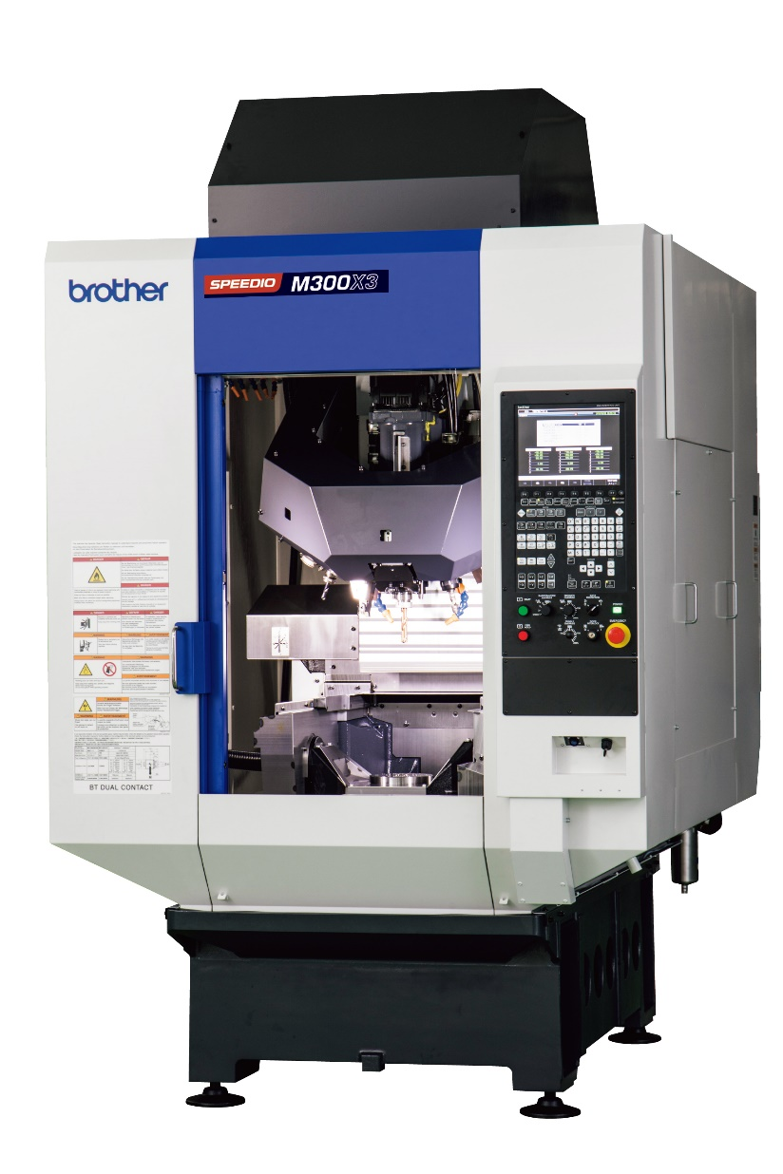

***Brother M300X3 SPEEDIO***

***Nakamura JX-250***

